**Sample preparation:**

1. Cut plaster / patch at size 2.5 x 7.5cm (dalam 15 keping)
2. Pour 100ml of petroleum ether into a clean 250ml beaker
3. Detach the plastic film and immerse the plasters/ patch into the petroleum ether for 30 minutes
4. Take out the plaster /patch and put into another beaker (ensure no more ointment stick on the plaster) using glass rod
5. Put extracted ointment in fumehood overnight for evaporation

**Sample digestion**

1. Weigh around **0.25g** of extracted ointment into weighing cup. Then put into digestion Teflon tubes
   * RB
   * IQC BLK Plaster
   * **IQC oint (kita punya IQC)** - spiked mix std (0.25ml)
   * **IQC oint (kita punya IQC)** - spiked mix std (0.25ml)
   * IQC A Plaster spiked mix std (0.25ml)
   * IQC B Plaster spiked mix std (0.25ml)
   * Plaster A
   * Plaster B
2. Add **6ml high purity HNO3 and 2ml H2o2** into each Teflon tube
3. Start digestion using microwave digestor. Program as below:   
   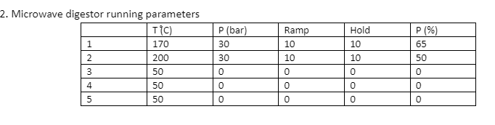
4. Filter the sample and markup to 25g in a bottle

**Determination**

1. Run ICPMS macam biasa
2. Rinse 2 x setiap injection